Downloading XAMPP from website

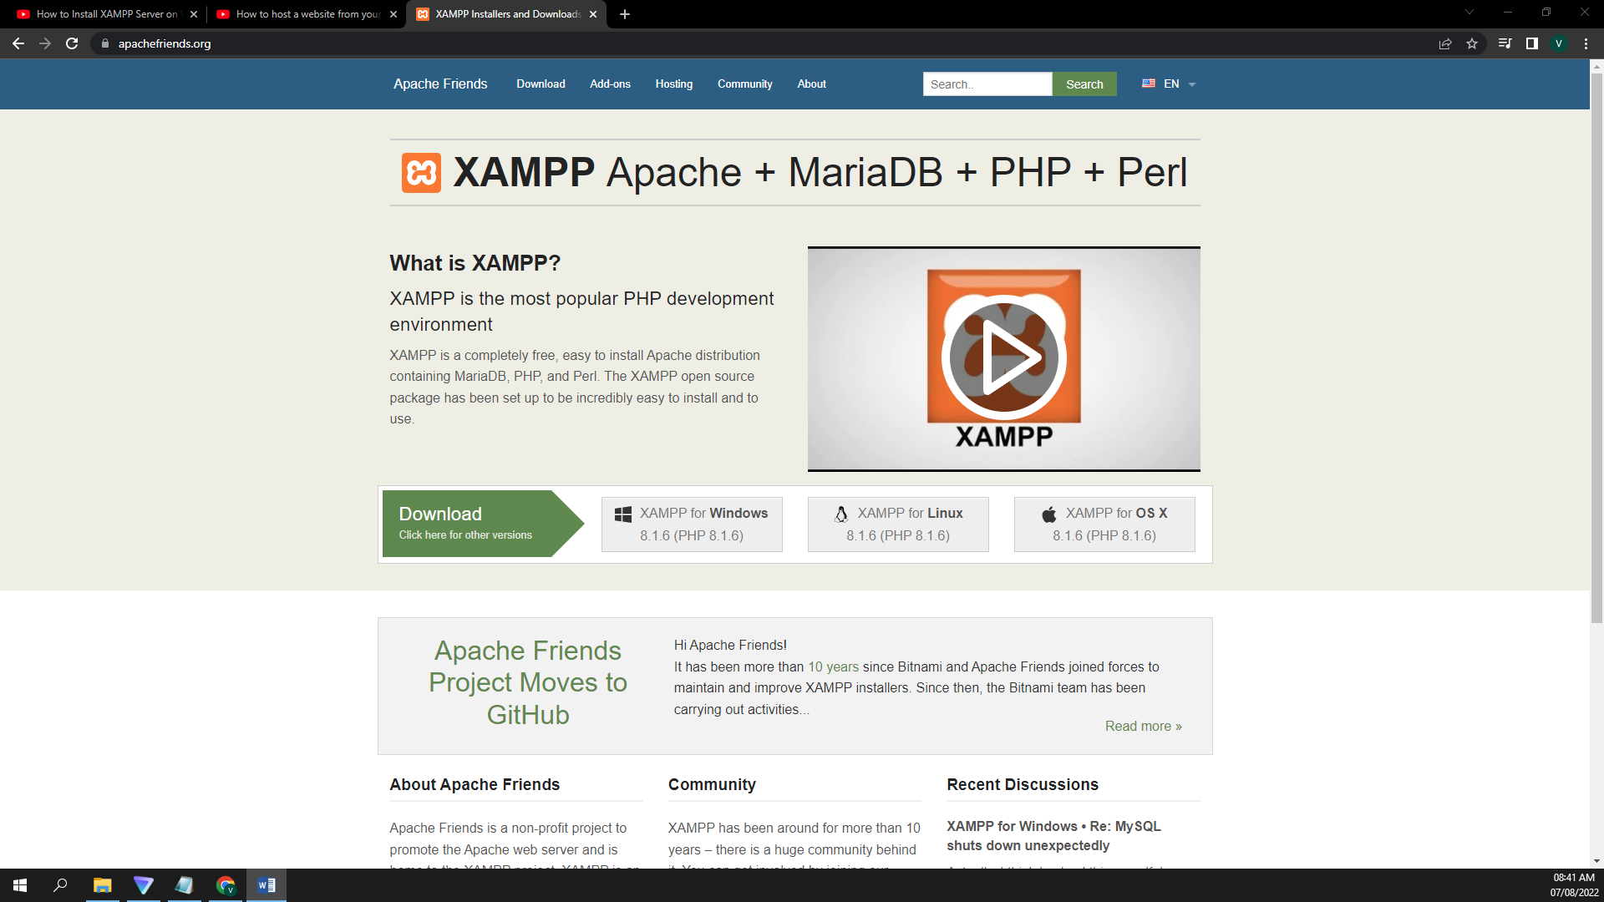

Installing the XAMPP Application

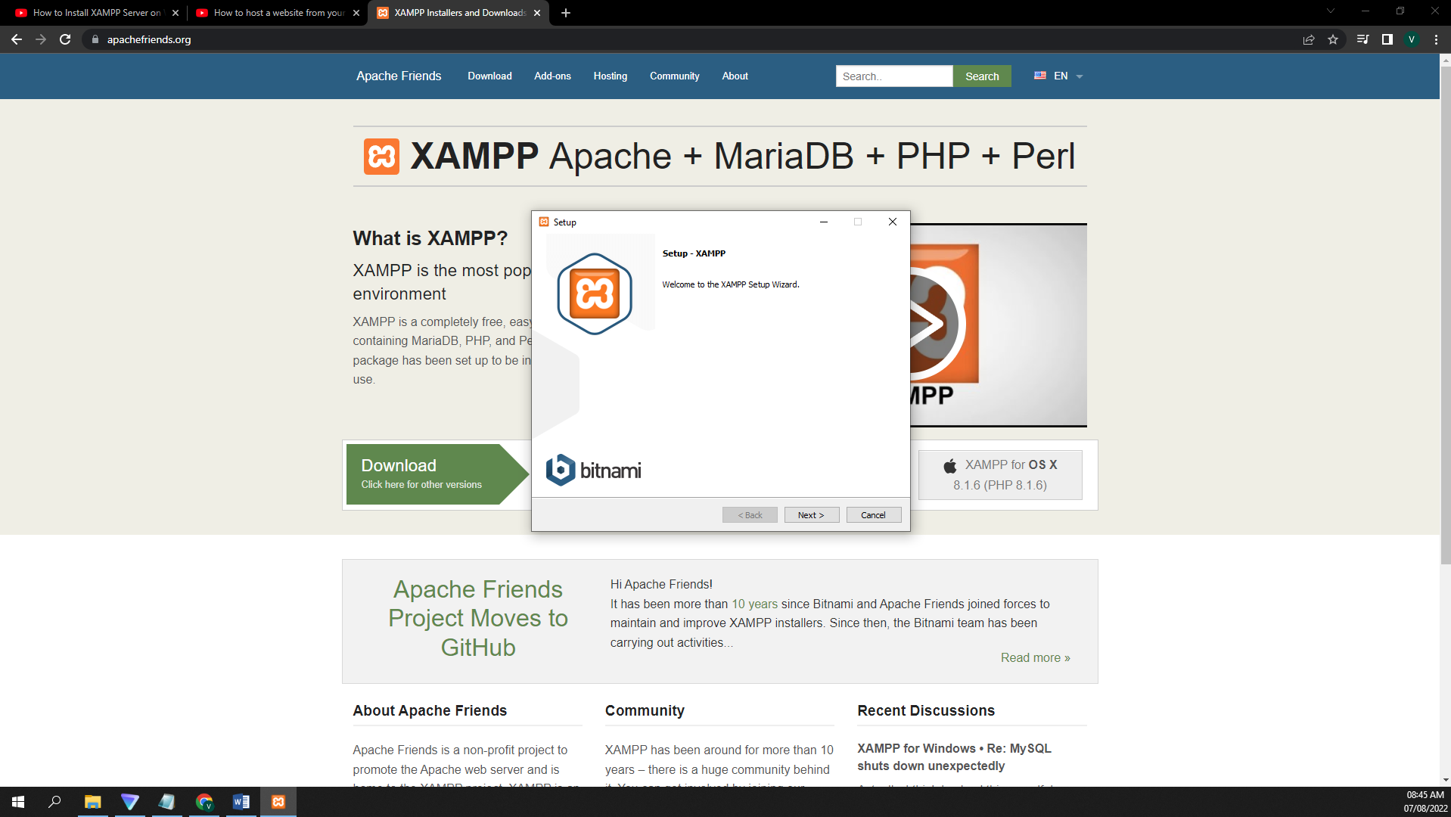

Selecting the services we need to install

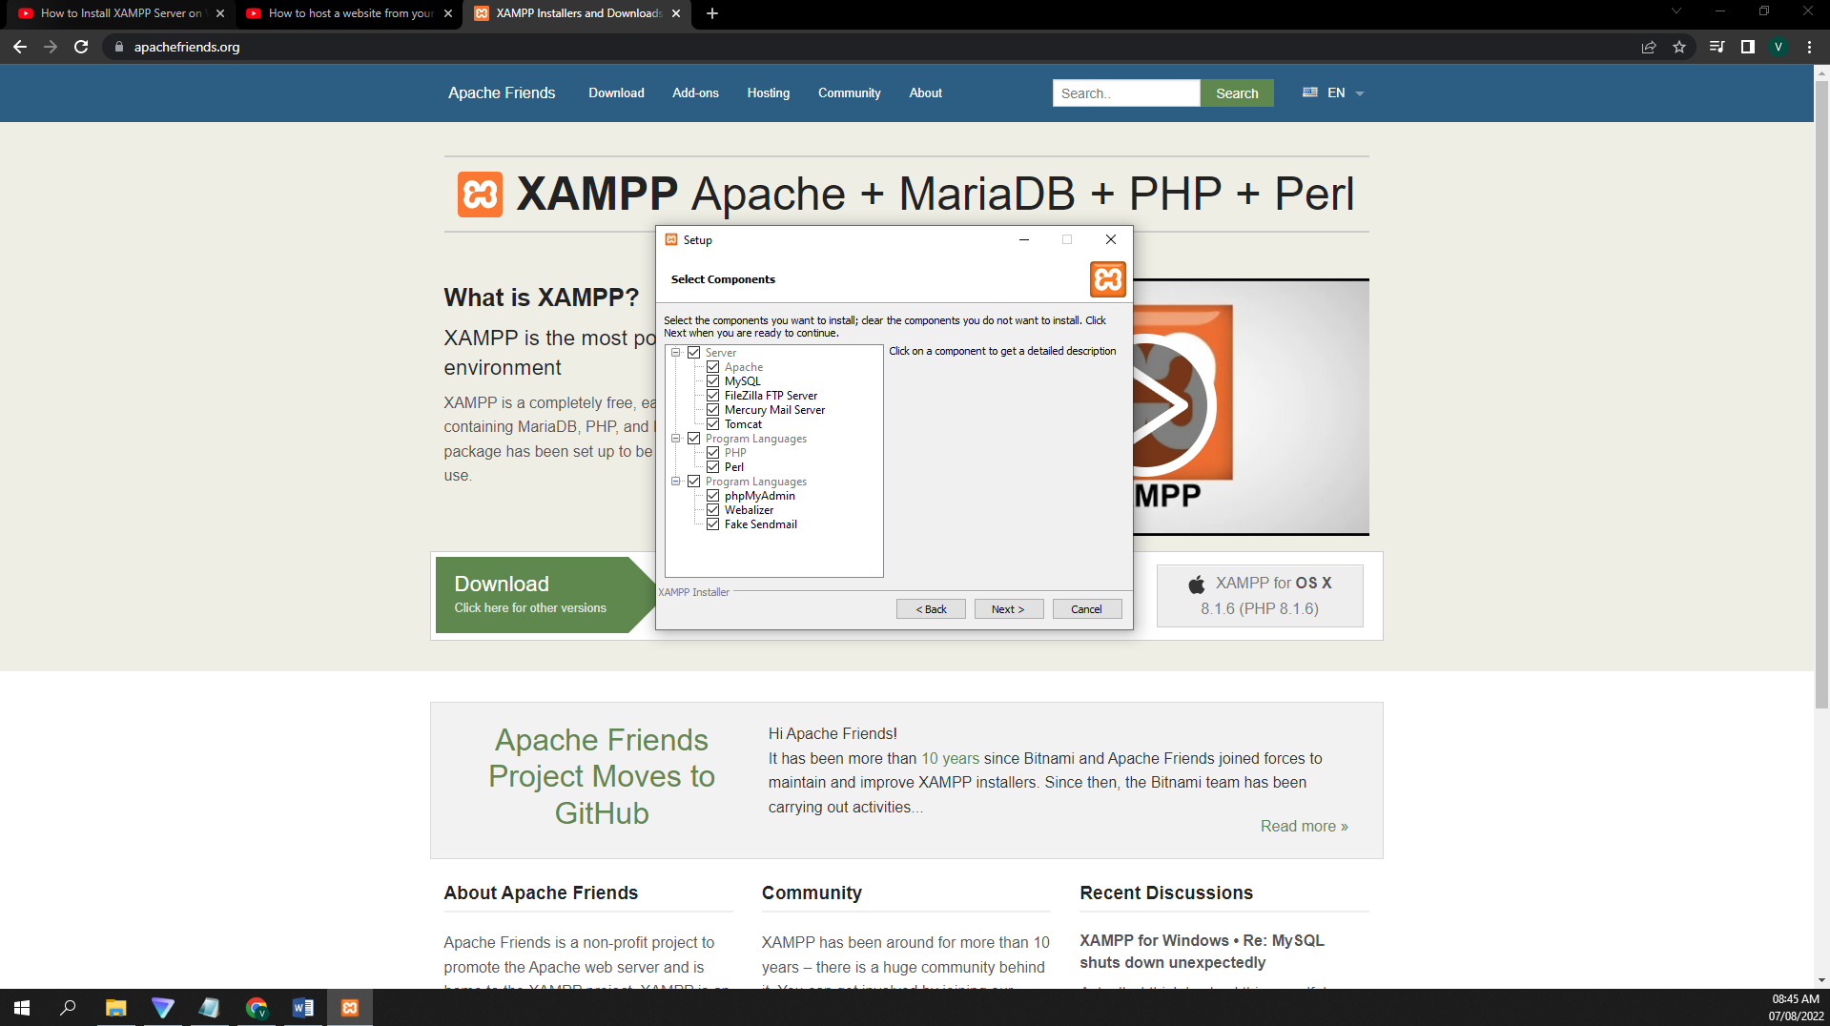

Selecting folder in which the XAMPP need to install

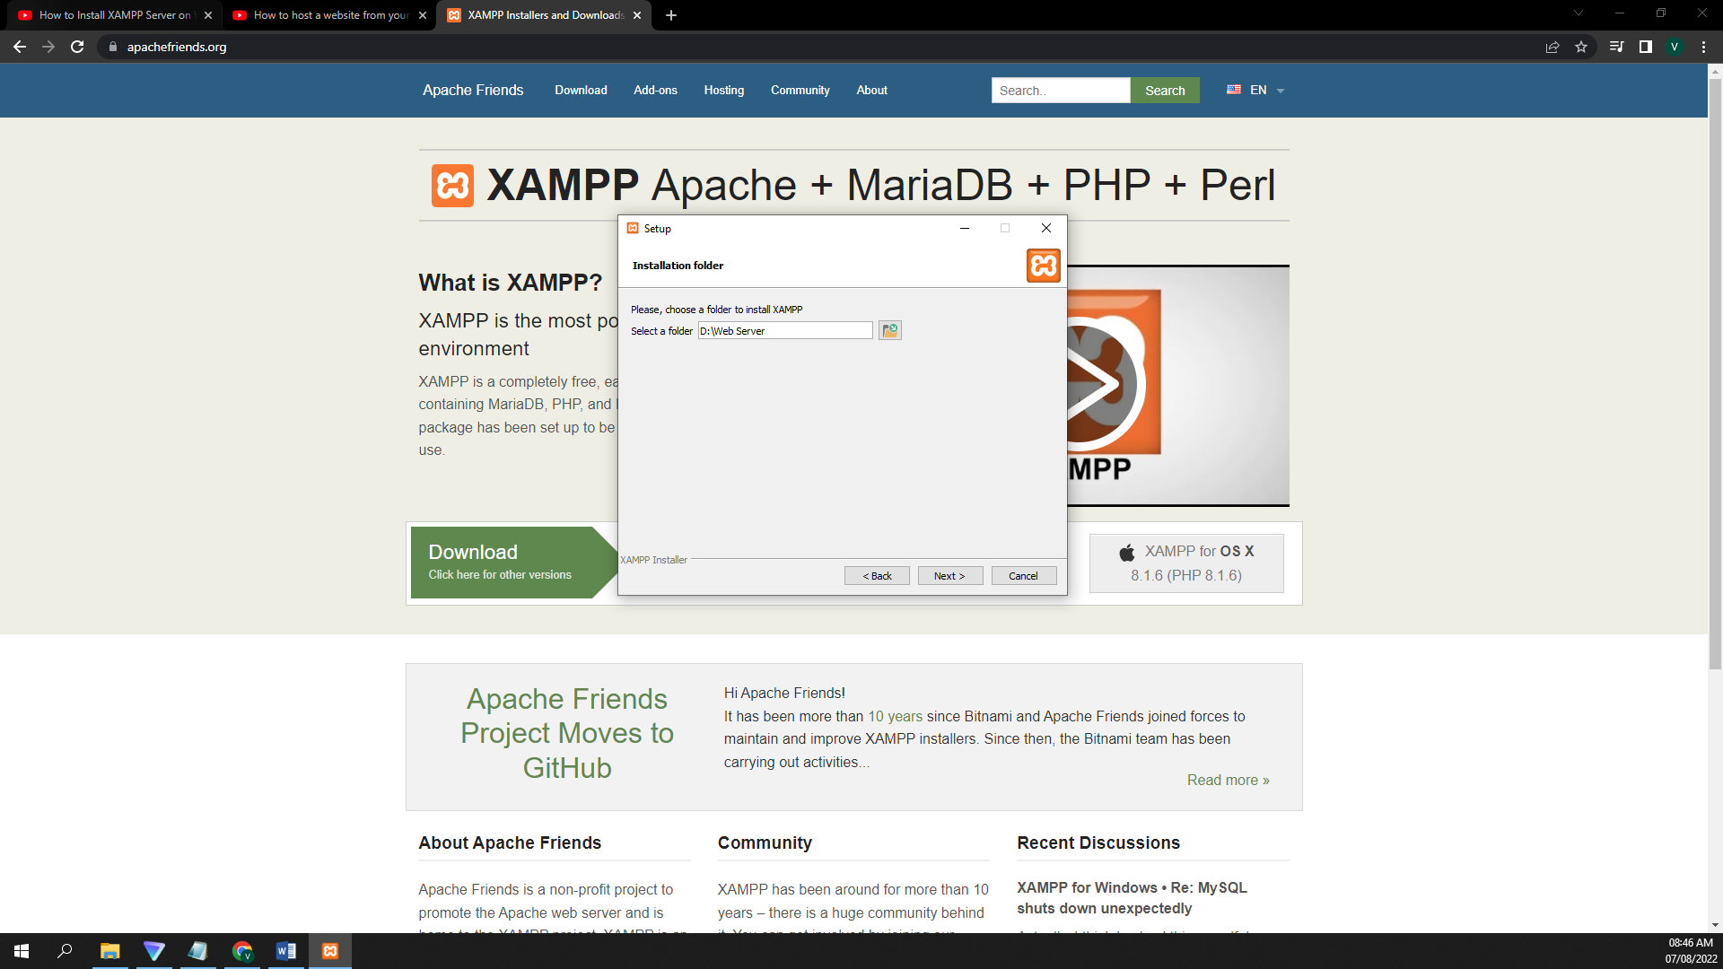

Processing of installation

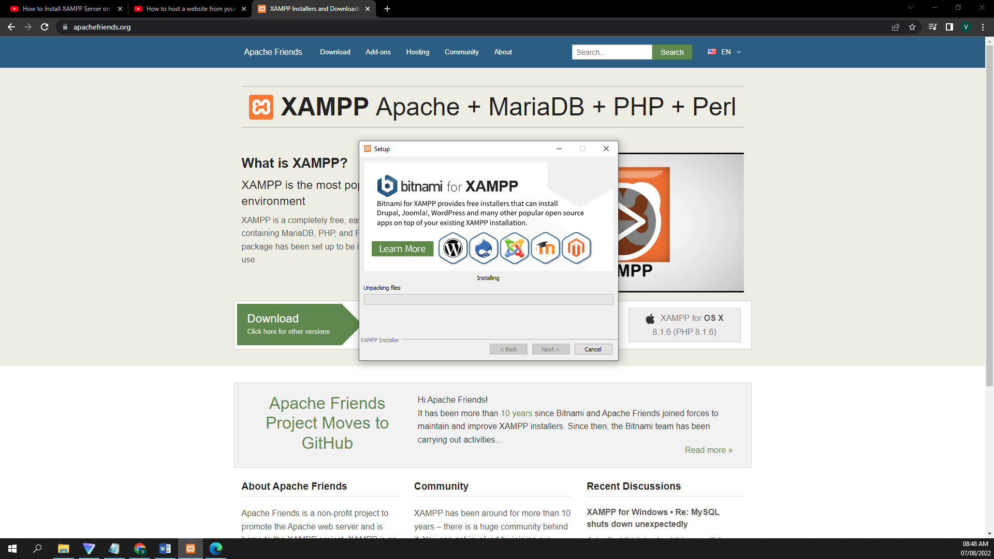

Done with the installation

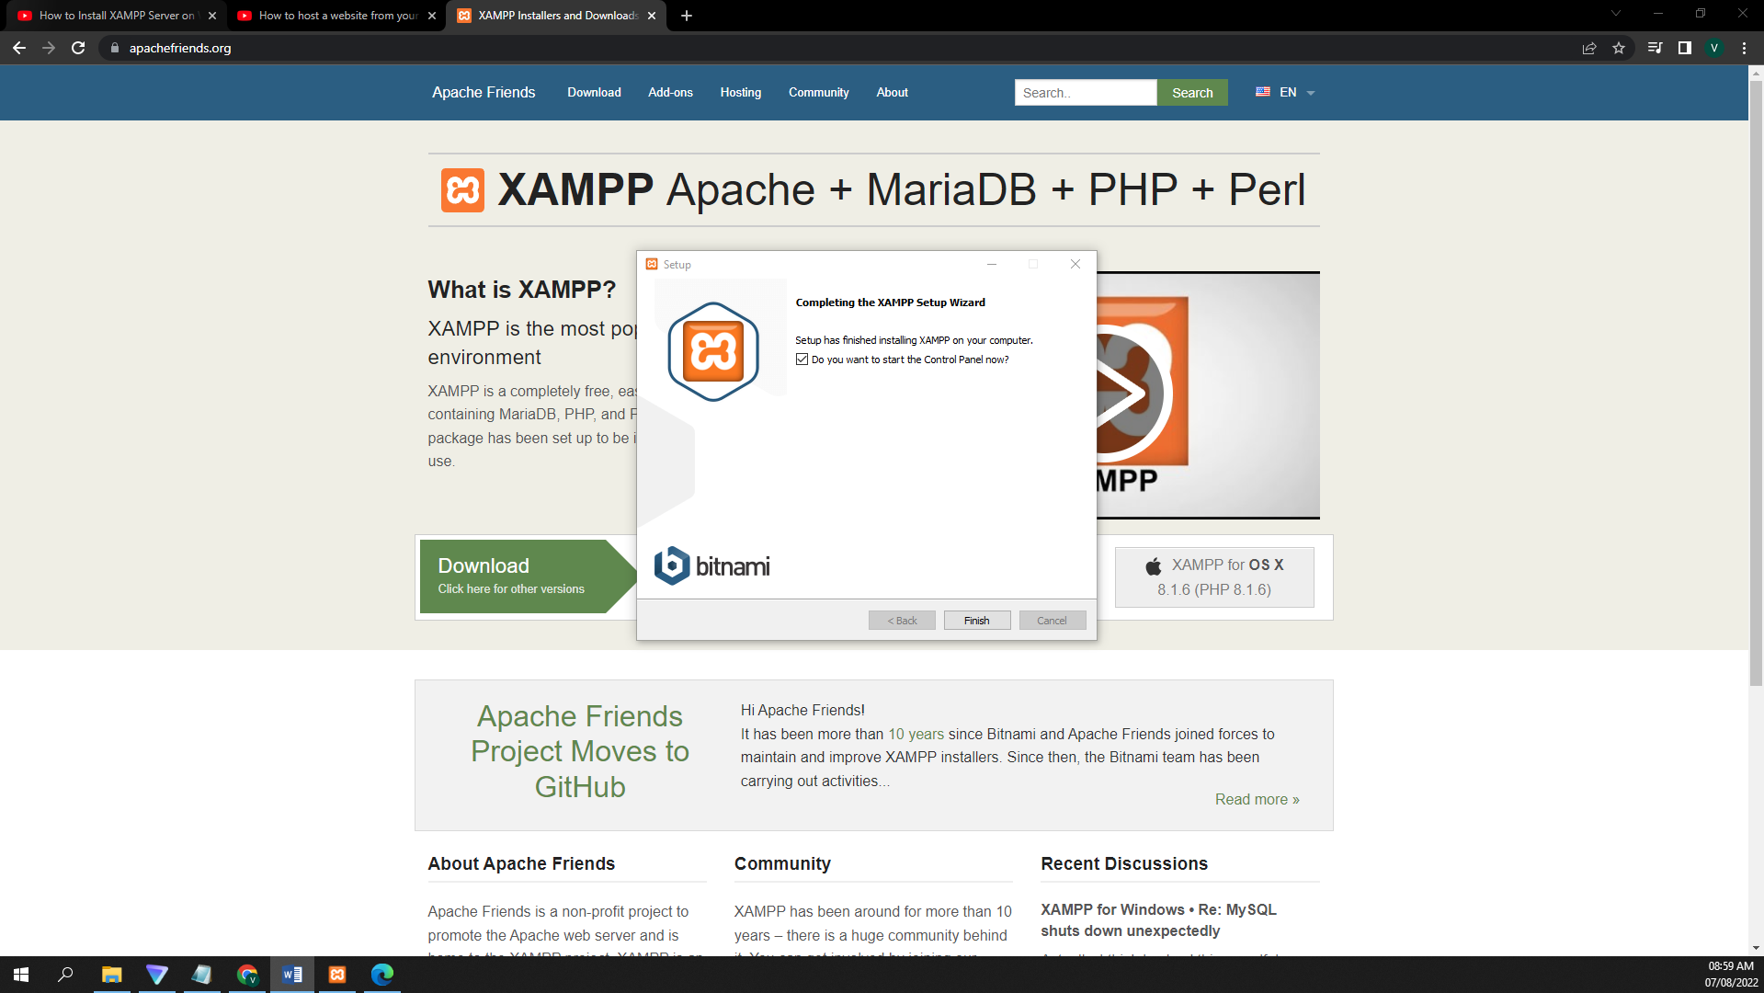

XAMPP Application interface and Running Apache Service

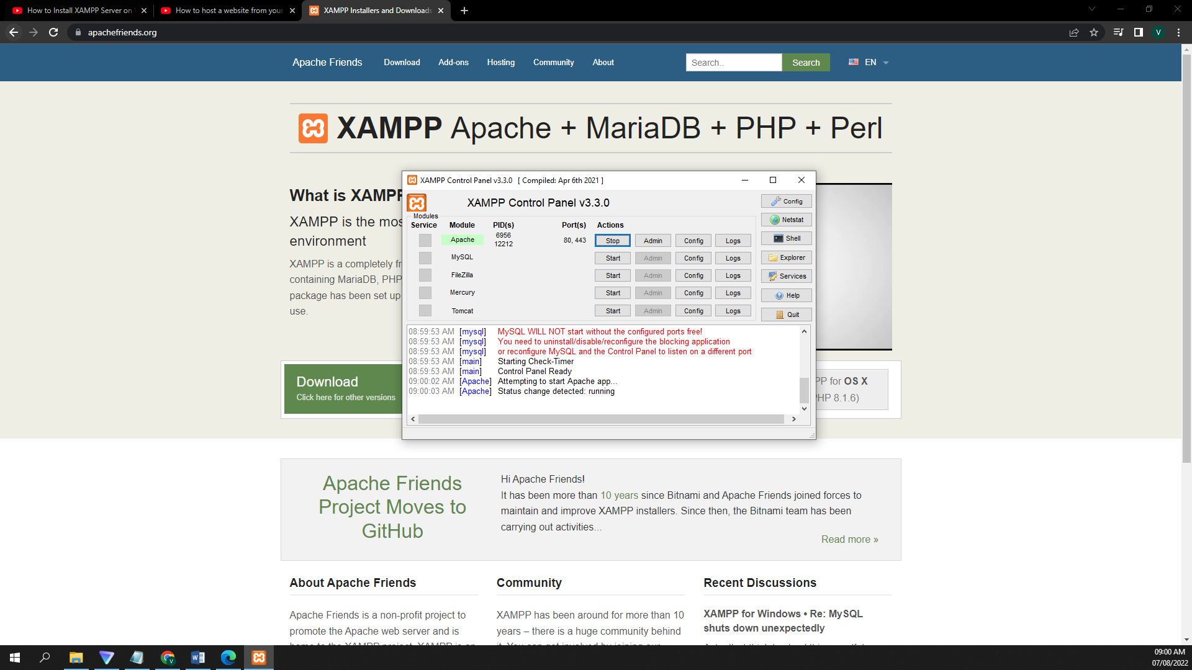

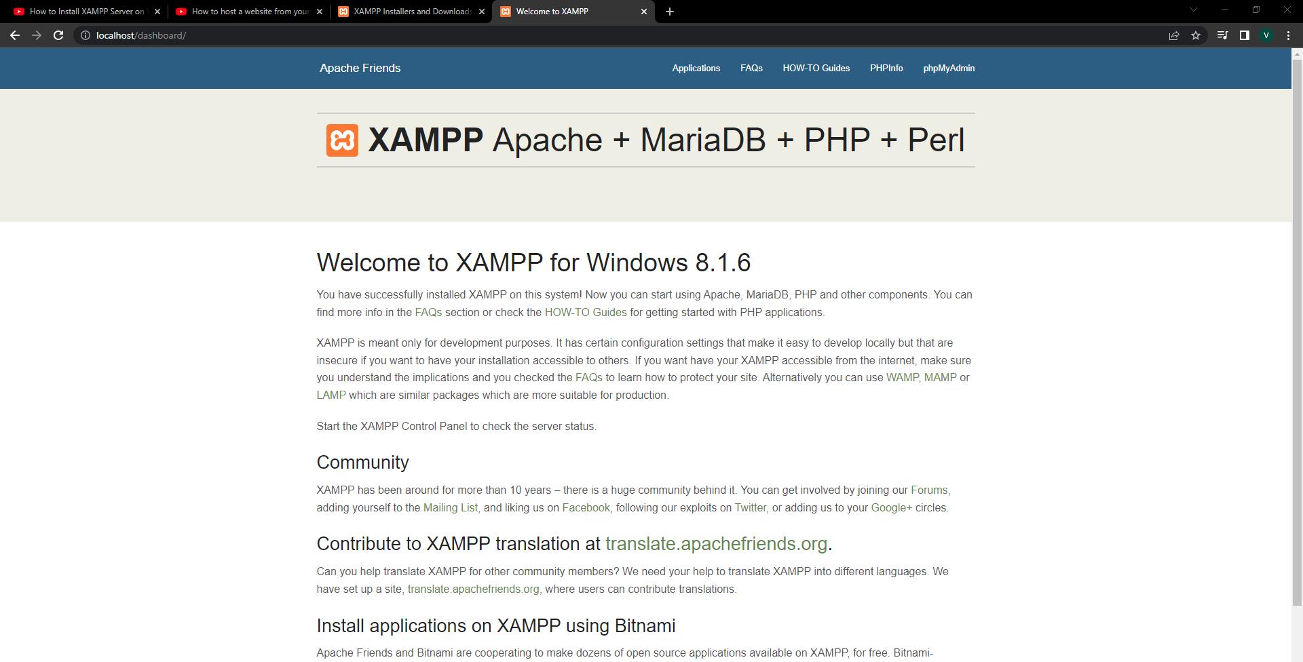

XAMPP ( or ) is a free and open-source cross-platform web server solution stack package developed by Apache Friends, consisting mainly of the Apache HTTP Server, MariaDB database, and interpreters for scripts written in the PHP and Perl programming languages.

It is easy enough to set up a Web server. Most Web browsers provide a login and password generator, can handle multiple client requests for a single user, and can send the resulting contents of the file to an FTP server. Web servers are also available for use as mail servers, web chat servers, web collaboration tools, file storage servers, and web application servers, where you can store your programs and data for future delivery.

Most Web servers provide the ability to load and run dynamic web applications. A web server must be conditioned to have these capabilities. Some server types, such as the Solaris 8 server, do not have such capability. In this case, your administrator must use another method to enable the dynamic web server.